### Experiment Number 1

# Aim : - Case Study on “Library Management System ”.

# Objective :-To study and Apply SDLC concepts to the above case study.

**Software Development Life Cycle (SDLC)**

SDLC is a systematic process used to design, develop, test, and maintain software. It encompasses several phases, including:

1. **Planning**: Defining project scope, objectives, and resources.
2. **Analysis**: Gathering requirements and understanding user needs.
3. **Design**: Creating system architecture and detailed specifications.
4. **Implementation**: Writing code and building the software.
5. **Testing**: Verifying functionality and identifying defects.
6. **Deployment**: Rolling out the software to users.
7. **Maintenance**: Ensuring ongoing support and updates.

[SDLC ensures efficient software development by following a structured approach from inception to completion1](https://biz.libretexts.org/Courses/Canada_College/Management_Information_Systems_Remix/10%3A_Information_Systems_Development/10.02%3A_Systems_Development_Life_Cycle_%28SDLC%29_Model). It’s essential for creating reliable, high-quality software systems.

**Library Management Systems**

A **Library Management System (LMS)** automates library operations, making them more efficient. Here are key aspects of LMS:

1. **Functional Requirements**:
   * **Books Management**: Store book information (title, author, genre, availability).
   * **User Management**: User accounts, profiles, and registration.
   * **Circulation Management**: Borrowing, returns, renewals, and fines.
   * **Reporting and Analytics**: Usage reports, inventory reports, etc.
2. **Non-Functional Requirements**:
   * **Performance**: Fast response times for queries and transactions.
   * **Scalability**: Handling increased load (horizontal and vertical scaling).
   * **Availability**: Minimal downtime for maintenance.
   * **Reliability**: Data integrity during transactions.

**Creating a Library Management System Project**

For a comprehensive project, consider these steps:

1. **Team Formation**: Assemble a dynamic team with diverse skills.
2. **Topic Selection**: Choose LMS as your project focus.
3. **Project Synopsis**: Define project goals and requirements.
4. **Requirement Gathering**: Create a Software Requirement Specification (SRS) document.
5. **Coding/Implementation**: Develop frontend, backend, and database components.
6. **Testing**: Thoroughly test the system.
7. **Project Presentation**: Showcase your work.
8. **Research Paper**: Write about your project.

Remember, each phase is crucial for successful project development. [Good luck! 😊📚👩‍💻 1](https://biz.libretexts.org/Courses/Canada_College/Management_Information_Systems_Remix/10%3A_Information_Systems_Development/10.02%3A_Systems_Development_Life_Cycle_%28SDLC%29_Model): [Systems Development Life Cycle (SDLC) Model](https://biz.libretexts.org/Courses/Canada_College/Management_Information_Systems_Remix/10%3A_Information_Systems_Development/10.02%3A_Systems_Development_Life_Cycle_%28SDLC%29_Model) [2](https://www.geeksforgeeks.org/library-management-system/): [Library Management System Project | Software Development](https://www.geeksforgeeks.org/library-management-system/)

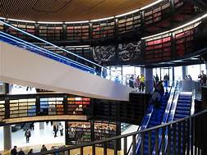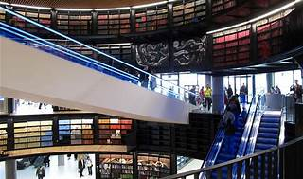

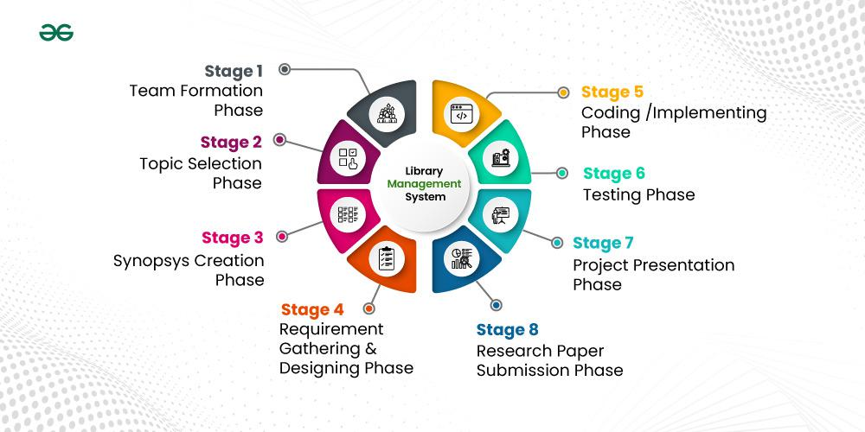

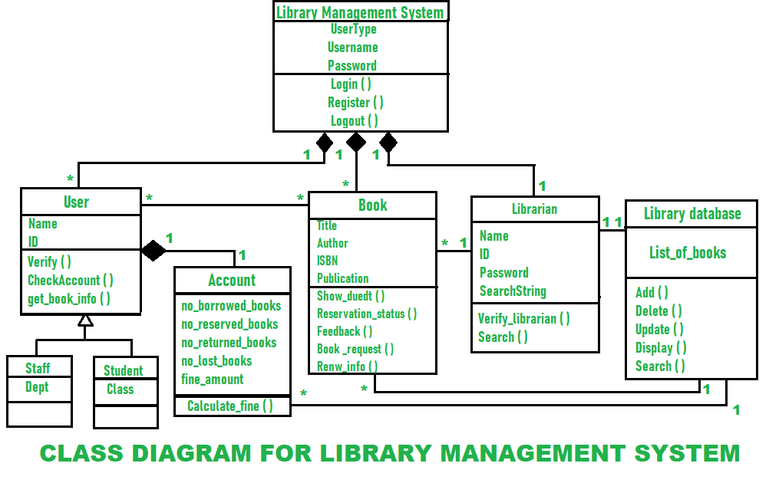

**Library Management Systems (LMS)**

1. **Follett Destiny Suite**:
   * **Strengths**: Optimized for quick response, easy to use, and suitable for both small businesses and mid-market.
   * **Features**: Includes **Destiny Library Manager** and **Destiny Resource Manager** for tracking and managing district resources.
   * [**User Satisfaction**: High user satisfaction1](https://www.g2.com/categories/library-management-systems).
2. **Atriuum ILS**:
   * **Strengths**: Easiest to use in library management systems.
   * **Features**: Comprehensive solution for libraries.
   * [**User Satisfaction**: Excellent](https://www.g2.com/categories/library-management-systems).
3. **OpenEduCat**:
   * **Strengths**: Best free software option.
   * **Features**: Offers library management capabilities.
   * **User Satisfaction**: Positive.

**Case Study: Implementing a User-Centric Library Management System**

**Background**

The fictional library, "Book Haven," is a bustling academic library serving a diverse community of students, faculty, and staff. The library aims to enhance its services by modernizing its manual library management system with a robust and user-friendly digital platform.

**Problem Statement**

The current manual system at Book Haven suffers from inefficiencies, inaccuracies, and limited accessibility. Manual record-keeping is time-consuming, prone to errors, and hinders the library's ability to provide timely services to its patrons.

**Proposed Solution**

The class diagram outlines the blueprint for a new Library Management System (LMS) to address the library's challenges. The system will streamline operations, improve user experience, and provide valuable insights for library management.

**System Architecture**

The LMS comprises the following key components:

* **User Management:** Handles user registration, authentication, and authorization for different user types (staff, students, librarians).
* **Book Management:** Manages book cataloging, searching, borrowing, returning, and reservation processes.
* **Library Database:** Stores comprehensive book information, user accounts, and transaction history.
* **Librarian Module:** Facilitates librarian-specific tasks like adding/updating books, managing user accounts, and generating reports.

**Key Features**

* **User-Friendly Interface:** Intuitive web-based interface for easy navigation and interaction.
* **Online Catalog:** Comprehensive search functionality to locate books by title, author, subject, or keyword.
* **Self-Service Options:** Online account management, book renewals, and reservation for users.
* **Real-Time Availability:** Up-to-date information on book availability and due dates.
* **Efficient Check-in/Check-out:** Barcode scanning or RFID technology for quick book transactions.
* **Fine Management:** Automated fine calculation and tracking.
* **Detailed Reports:** Customizable reports for library usage analysis and resource management.

**Benefits**

* **Improved Efficiency:** Streamlined workflows and reduced manual tasks.
* **Enhanced User Experience:** Convenient access to library resources and services.
* **Accurate Data Management:** Reliable book records and user information.
* **Data-Driven Decision Making:** Valuable insights for optimizing library operations.

**Implementation and Evaluation**

The LMS will be developed using a combination of open-source software and custom-built components. The system will be thoroughly tested for functionality, security, and user experience before deployment. User feedback will be collected to refine the system and ensure it meets the evolving needs of the library community.

**Additional Considerations**

* **Mobile Accessibility:** Develop a mobile app for on-the-go access to library services.
* **Integration with Other Systems:** Integrate with the university's student information system for user authentication and data sharing.
* **Data Security and Privacy:** Implement robust security measures to protect sensitive user and book data.

**Conclusion**

* By implementing the LMS, Book Haven aims to transform its library services, providing a seamless and efficient experience for its patrons while empowering library staff with valuable tools for managing the collection and resources effectively.